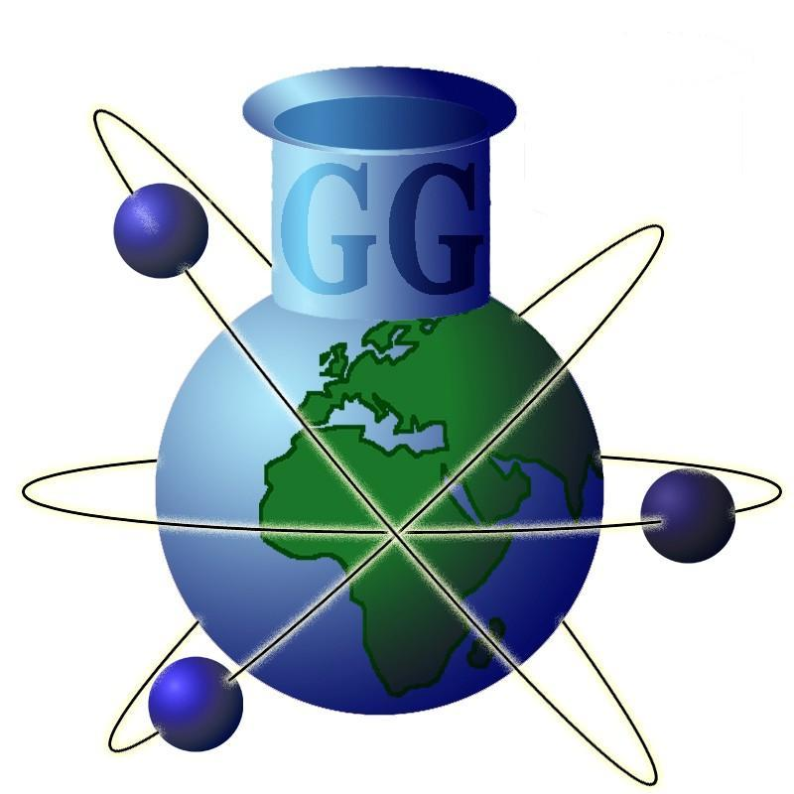 | Geochemistry  Group  of the  Mineralogical  Society  and of the  Geological  Society
Registered charity nos.
233706 & 210161, respectively
Dr George Cooper
Secretary of the Geochemistry Group

School of Earth and Environmental Sciences
Cardiff University
Park Place
Cardiff
CF10 3AT
Email: CooperG3@cardiff.ac.uk

Geochemistry Group Postdoctoral Researcher Medal Application Form

The Geochemistry Group welcomes applications for the Postdoctoral Researcher Medal, awarded in recognition of an outstanding peer-reviewed geochemical paper published by a postdoctoral researcher based at a UK or Irish university or research institution. The medal is open to researchers who hold a PhD and are on a temporary research contract that is not an independent research fellowship with a duration of more than 36 months. Full eligibility criteria are listed in the attached appendix; please get in touch if you want to clarify your eligibility.
The award aims to promote the work of post-doctoral researchers who are not independent research fellows by recognising their outstanding research contribution. One recipient will win the medal each year, based on the publication’s innovation, novelty and significance to its field. Medal winners will also be invited to give a keynote lecture at the Geochemistry Group’s annual Research in Progress (GGRiP) meeting.
There is one application round per year, with a deadline of 15th January. Applications are accepted throughout the calendar year but will not be judged before the deadline. Details of any adjustments to this date and other relevant information will be published on the Geochemistry Group’s website, www.geochemistry.group, and/or through the group’s social media pages.
To apply, the researcher should email the Geochemistry Group secretary with the following attachments:
- A completed application form.
- A letter of support. The letter should not exceed one side of A4, and needs to clearly state the contribution to science made by the publication. Note that the letter is not intended to support the nominee, only the impact, novelty and innovation of the nominated publication.
- A copy of the manuscript.

Please contact the Geochemistry Group’s secretary, Dr George Cooper, if you require any further information about this program.

Personal Details
Name
Institution
Postal address
Phone
Email
Position
Source of funding
Nominating letters of support from

Publication Information
Title
Journal
Citation information or DOI
Abstract

In submitting this application I confirm that the above details are correct and provide consent for the Geochemistry Group and its parent bodies (The Mineralogical Society of Great Britain and Ireland and the Geological Society of London) to gather personal information in order to provide you with services relating to the Group. These data will be stored electronically for a period of not more than three years and will be used to contact you in relation to the Geochemistry Group only.

Please tick this box if you wish to be added to the Geochemistry Group’s mailing list to receive updates on the group’s activities and information relating to other Special Interest Groups.

We ask all applicants to complete an optional equality, diversity & inclusion questionnaire after submission (time to complete: < 2 minutes). Their sole purpose is to help us evaluate the impact of our actions on diversity within the Geochemistry Group activities. All replies will be processed anonymously via a Google Form. If you do NOT wish to take part in this survey, please tick this box.

Signed: Date:

Appendix: Eligibility criteria for the Geochemistry Group Postdoctoral Researcher Medal
- Applicants must be nominated by one letter of support. Applicants are responsible for obtaining the letter of support and must send it alongside a completed application form and an electronic copy of the nominated publication to the Geochemistry Group Secretary before the application deadline. The nomination letter must not exceed one side of A4 and should state how the publication (not the nominee) is innovative, novel and significant within its field.
- The applicant must be the first author of the nominated paper.
- Applicants must be based at a university or research institution within the U.K. or Ireland.
- Applicants must hold a PhD at the time of applying and not have a permanent contract at their institution. Postdoctoral Research Associates (PDRAs), University Research Fellows (URFs) and researchers with institutional or alternative funding sources (e.g. Marie Curie or Leverhulme) are all welcome to apply, but researchers holding Independent Research Fellowships with durations more than 36 months (e.g. NERC fellows or Royal Society URFs) are not eligible for the award. Please contact the Geochemistry Group’s secretary, Dr George Cooper, for clarification on specific circumstances.
- The research presented in the paper submitted for the award may have been undertaken during the PhD of the applicant.
- Applicants who attain a permanent position or independent research fellowship after the application deadline has passed will still be considered for the award.
- If an applicant moves abroad after submitting an application, they are required to inform the Geochemistry Group.
- Nominated papers will be judged by the Geochemistry Group committee according to their innovation, novelty and significance to the field. It is stressed that the journal’s impact factor will not be considered.
- There is one application round per year, with a deadline of 15th January.
- The nominated paper must have a DOI from the previous calendar year (i.e. for applications submitted for the January 2016 deadline, the paper must have a 2015 DOI). Papers are considered published once the DOI is available (i.e. accepted but non-proof ready articles that are available online are eligible for the award).
- Applicants will be notified of the outcome of their application within 30 days of the submission deadline.
- The medal and certificate will be awarded to the successful applicant at the following Geochemistry Group’s Research in Progress meeting, which is usually held in March/April (see the website for further information). It is also expected that the successful candidate will present a keynote seminar at this meeting.
- No financial award is associated with the medal, other than free-registration for the GGRIP meeting where the award will be presented and reimbursement of travel and accommodation to attend that meeting.
- Members of the Geochemistry Group steering committee are allowed to apply to the Group's bursaries and awards under the following conditions:
  - They will have to step out of the meeting for the discussion where their application is reviewed.
  - They may not apply to more than one award/bursary in a given year.
  - They may not apply to any Geochemistry Group funding while in receipt of a live award.

