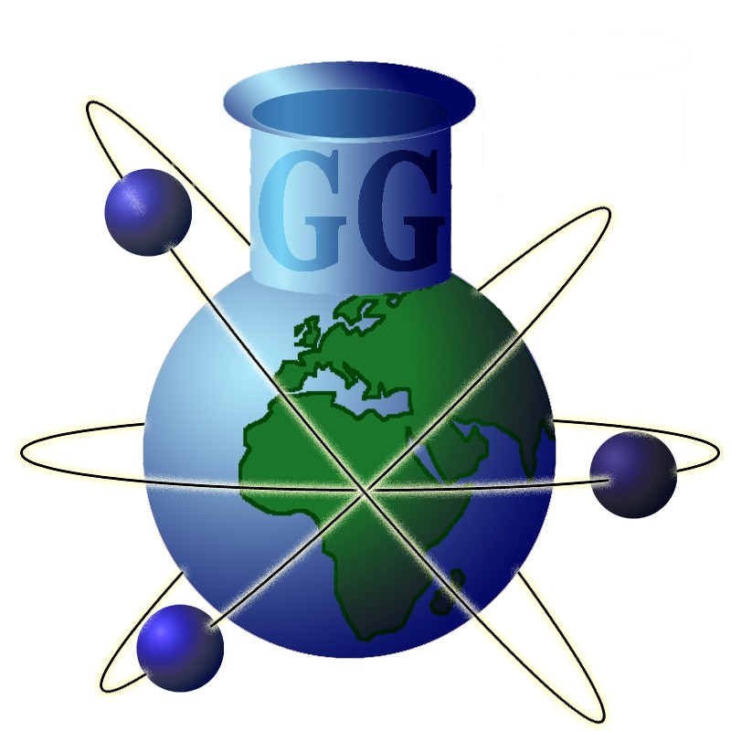 | Geochemistry  Group  of the  Mineralogical  Society  and of the  Geological  Society
Registered charity nos.
233706 & 210161, respectively
Dr Marie-Laure Bagard
Secretary of the Geochemistry Group

Department of Earth Sciences
University of Cambridge
Downing Street Cambridge
Cambridgeshire CB2 3EQ
United Kingdom
Tel: +44 (0)1223 333452
Email: mlb63@cam.ac.uk

Geochemistry Group Postdoctoral Researcher Medal Application Form

The Geochemistry Group welcomes applications for the Postdoctoral Researcher Medal, awarded in recognition of an outstanding peer-reviewed scientific geochemical paper published by a postdoctoral researcher based in the UK or Ireland. The medal is open to researchers who hold a PhD, are on a temporary research contract that is not an independent research fellowship, and are currently based at an eligible institution. Full eligibility criteria are listed in the attached appendix.
The award aims to promote the work of post-doctoral researchers who are not independent research fellows by recognising their outstanding research contribution. One recipient will win the medal each year, based on the publication’s innovation, novelty and significance to its field. Medal winners will also be invited to give a keynote lecture at the Geochemistry Group’s annual Research in Progress (GGRiP) meeting.
To apply, the researcher should be nominated by one letter of support. The letter should not exceed one side of A4, and needs to clearly state the contribution to science made by the publication. Note that the letter is not intended to support the nominee - only the impact, novelty and innovation of the nominated publication. In addition to the nomination letter, the applicant should complete and submit this form to the Geochemistry Group’s secretary together with a copy of the manuscript.
There is one application round per year, with a deadline of 15th January. Details of any adjustments to this date and other relevant information will be published on the Geochemistry Group’s website, www.geochemistry.group, and/or through the group’s social media pages.
Please contact the Geochemistry Group’s secretary, Dr Marie-Laure Bagard if you require any further information about this program.

Personal Details
Name
Institution
Postal address
Phone
Email
Position
Source of funding
Nominating letters of support from

Publication Information
Title
Journal
Citation information or DOI
Abstract

In submitting this application I confirm that the above details are correct and provide consent for the Geochemistry Group and its parent bodies (The Mineralogical Society of Great Britain and Ireland and the Geological Society of London) to gather personal information in order to provide you with services relating to the Group. These data will be stored electronically for a period of not more than three years and will be used to contact you in relation to the Geochemistry Group only.

Please tick this box if you wish to be added to the Geochemistry Group’s mailing list to receive updates on the group’s activities and information relating to other Special Interest Groups.

We ask all applicants to complete an optional equality, diversity & inclusion questionnaire after submission (time to complete: < 2 minutes). Their sole purpose is to help us evaluate the impact of our actions on diversity within the Geochemistry Group activities. All replies will be processed anonymously via a Google Form. If you do NOT wish to take part in this survey, please tick this box.

Signed: Date:

Appendix: Eligibility criteria for the Geochemistry Group Postdoctoral Researcher Medal
- Applicants must be nominated by one letter of support.
- Applicants are responsible for obtaining the letter of support and must send the letter alongside a completed application form and an electronic copy of the nominated publication to the Geochemistry Group Secretary before the application deadline.
- The nomination letter must not exceed one side of A4 and should state how the publication (not the nominee) is innovative, novel and significant within its field.
- The applicant must be the first author of the nominated paper.
- Applicants must be based at a university or research institution within Great Britain or Ireland.
- Applicants must hold a PhD at the time of applying and not have a permanent contract at their institution. Postdoctoral Research Associates (PDRAs) and University Research Fellows (URFs) and researchers with institutional or alternative funding sources are all welcome to apply, but researchers holding Independent Research Fellowships (e.g. NERC fellows or Royal Society URFs) are not eligible for the award.
- The research presented in the paper submitted for the award may have been undertaken as part of the PhD of the applicant.
- Applicants who attain a permanent position or independent research fellowship after the application deadline has past will still be considered for the award.
- If an applicant moves abroad after submitting an application they are required to inform the Geochemistry Group.
- Nominated papers will be judged by the Geochemistry Group committee according their innovation, novelty and significance to its field. It is stressed that the journal’s impact factor will not be considered.
- There is one application round per year, with a deadline of 15th January.
- The nominated paper must have a DOI from the previous calendar year (i.e. for applications submitted in Jan 2016, the paper must have a 2015 DOI). Papers are considered published once the DOI is available (i.e. accepted but non-proof ready articles that are available online are eligible for the award).
- Applicants will be notified of the outcome of their application within 30 days of the submission deadline.
- The medal and certificate will be awarded to the successful applicant at the following Geochemistry Group’s Research in Progress meeting, which is usually held in March/April (see the website for further information). It is also expected that the successful candidate will present a keynote seminar at this meeting.
- No financial awards are associated with the award, other than free-registration for the GGRIP meeting where the award will be presented.

